--Question 1: What's wrong with the below query.

SELECT DISTINCT

a.EmpName,

c.DeptName,

b.Salary

FROM Emps AS a, Pay AS b, Depts AS c

WHERE a.empID = b.empID AND

c.DeptName LIKE 'JPM%';

Result set from select queries.

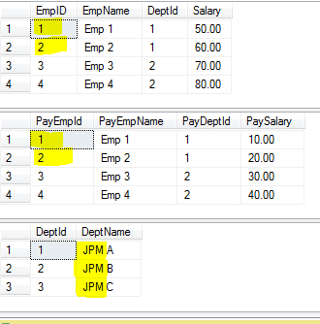

O/P: because the join condition is evaluated as join on Emp, Pay and JPM

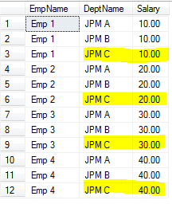

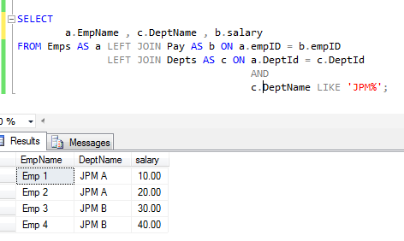

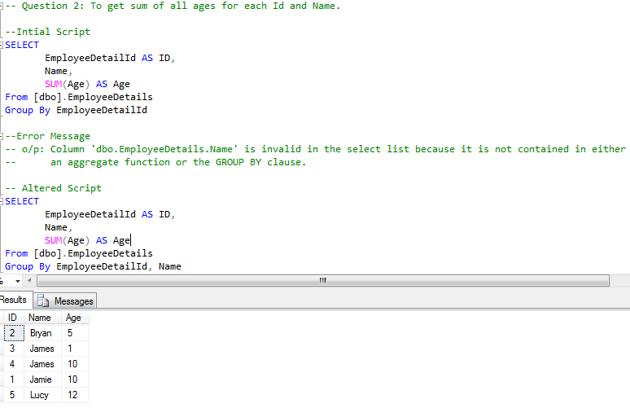

--**Question 3:** Why no rows are returned

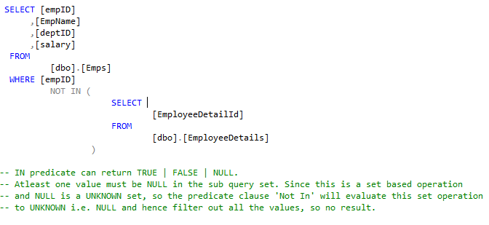

Problem:

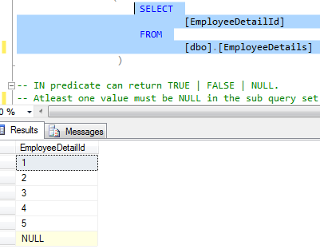

**Question 4:** Different ways to write unique values



